**Web Site Name**

***Landon Leigh***

***10/2/2020***

## Project Name: [provide a name for your project]

## Project Overview:

Describe your proposed website. Must include the following information:

* + Describe your application and its purpose.
    - * This application will provide information on Occupational Therapy and allow the user to study and learn information and provide resources and links for users.
  + Intended users of the website.
    - * Students in school for Occupational Therapy and users studying for taking the board exams.
  + Overview of the content of the website
    - * General information on the topic, a page that quizzed the user based on category they choose, page that links to resources for students, study plan/calendar page.

## Client Information:

* + Name of the client
    1. Elizabeth Capps
  + Organization/Institute/Business the client/s are associated with
    1. Student at Wingate University
  + Client’s valid email address
    1. Elizabethcapps98@gmail.com
  + Client’s phone number (if they are willing to share)
    1. 7048608290

## Site Map:

Before you start coding, you need to understand what pages you will need to create and how you will navigate between them. Below is an example of a site map. Please produce a site map for your application: (you can use https://www.gloomaps.com/or something similar).

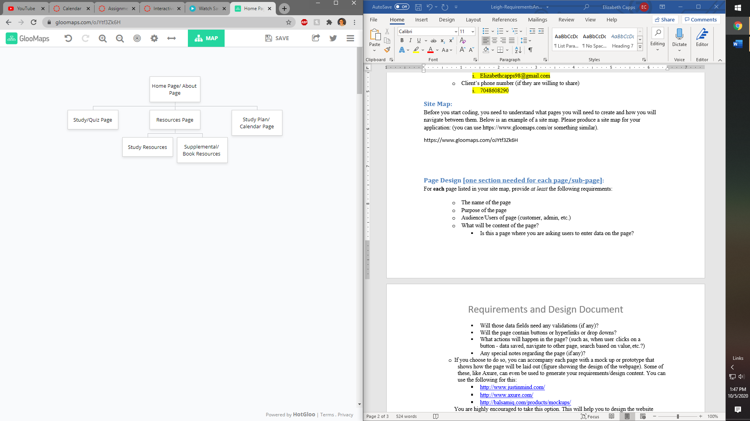

## Page Design [one section needed for each page/sub-page]:

For **each** page listed in your site map, provide *at least* the following requirements:

* + Home
  + Purpose of the page: Provide general information about Occupational Therapy
  + Audience/Users of page: Students of OT and people inquiring about it
  + What will be content of the page? Information on the career and role of Occupational Therapy
    - Is this a page where you are asking users to enter data on the page? No
    - Will those data fields need any validations (if any)? No
    - Will the page contain buttons or hyperlinks or drop downs? Potentially hyperlinks
    - What actions will happen in the page? Navigation
  + Study
  + Purpose of the page: Provides user with a quiz from different topics that test their knowledge to help prepare for classes or exams.
  + Audience/Users of page: Students of OT
  + What will be content of the page? List of topics that when selected many study questions will come up and after completion user will receive score.
    - Is this a page where you are asking users to enter data on the page? Yes
    - Will those data fields need any validations (if any)? Yes
    - Will the page contain buttons or hyperlinks or drop downs? Yes
    - What actions will happen in the page? Data will be saved to determine score at end.
  + Resources
  + Purpose of the page: Provides a list of items and links that will allow the student to purchase to assist in their learning process
  + Audience/Users of page: OT students
  + What will be content of the page? Links to websites such as amazon to purchase books or study materials and tools.
    - Is this a page where you are asking users to enter data on the page? No
    - Will those data fields need any validations (if any)? No
    - Will the page contain buttons or hyperlinks or drop downs? Hyperlinks
    - What actions will happen in the page? Navigation to other page in new window
  + Study Plan / Calendar
  + Purpose of the page: Provide a calendar to input text dates to assist in study planning
  + Audience/Users of page: Students planning study schedule
  + What will be content of the page? Calendar that allows topics to be posted on certain dates
    - Is this a page where you are asking users to enter data on the page? Yes
    - Will those data fields need any validations (if any)? No
    - Will the page contain buttons or hyperlinks or drop downs? Yes
    - What actions will happen in the page? Data saved and updated page

## Note: in some cases, the page displayed might be composed of several underlying pages which should have their own listing (header, footer, navigation bars, etc.). The content of these sub-pages should be reported once. Not repeated on every display page.

## Dynamic Functionality on the Website:

Describe the dynamic functionality you will implement using JavaScript- this is a description of the interactivity, for example, forms, calculators, interactive images, photo gallery that you wish to implement on your website. Specify the name of your webpage where you plan to use a certain interactivity and explain the reason. Provide example of URLs of web pages/websites where you found the interactivity that you would like to implement on your website.

Home Page: a Photo gallery potentially that will allow users to view images related to Occupational Therapy. <https://galleriajs.github.io/> has a gallery with a similar function.

Study Page: a form that will provide a list of topics that the user can choose from and once chosen, a quiz pops up that is from the chosen topic so that the user can test their knowledge. <https://www.codeconquest.com/coding-quizzes/html-knowledge-quiz/> has a similar functioning quiz.

Resources Page: interactive images that will navigate user to the website to purchase material.

Calendar/Study Plan Page: A calendar will be included that allows user to place events on certain days to remind them of what is due and when they can complete/study topics. <https://fullcalendar.io/> has a calendar similar to what is wanted.